# find Assignment

**Mandatory:**

1. Search and display all *.c and *.h files in all subdirectories starting from current directory

1. Search and display all directories in all subdirectories starting from current directory

Ans: find . -type d

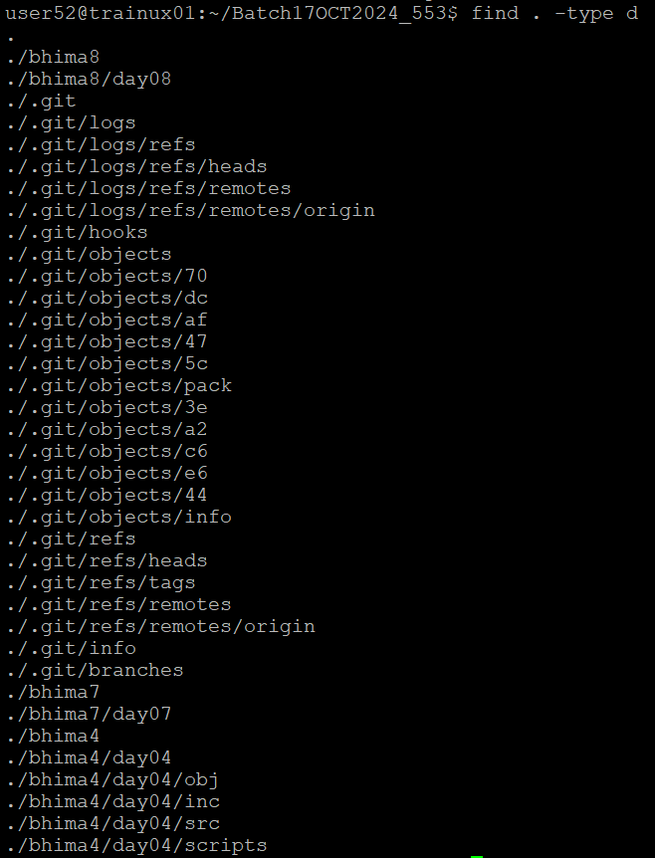

1. Search and display all files with permissions only rw with user and execute permission for others

Ans: find . -type f -perm 0601 or find . -type f -perm -u=rw,o=x commands can be used to display as mentioned above